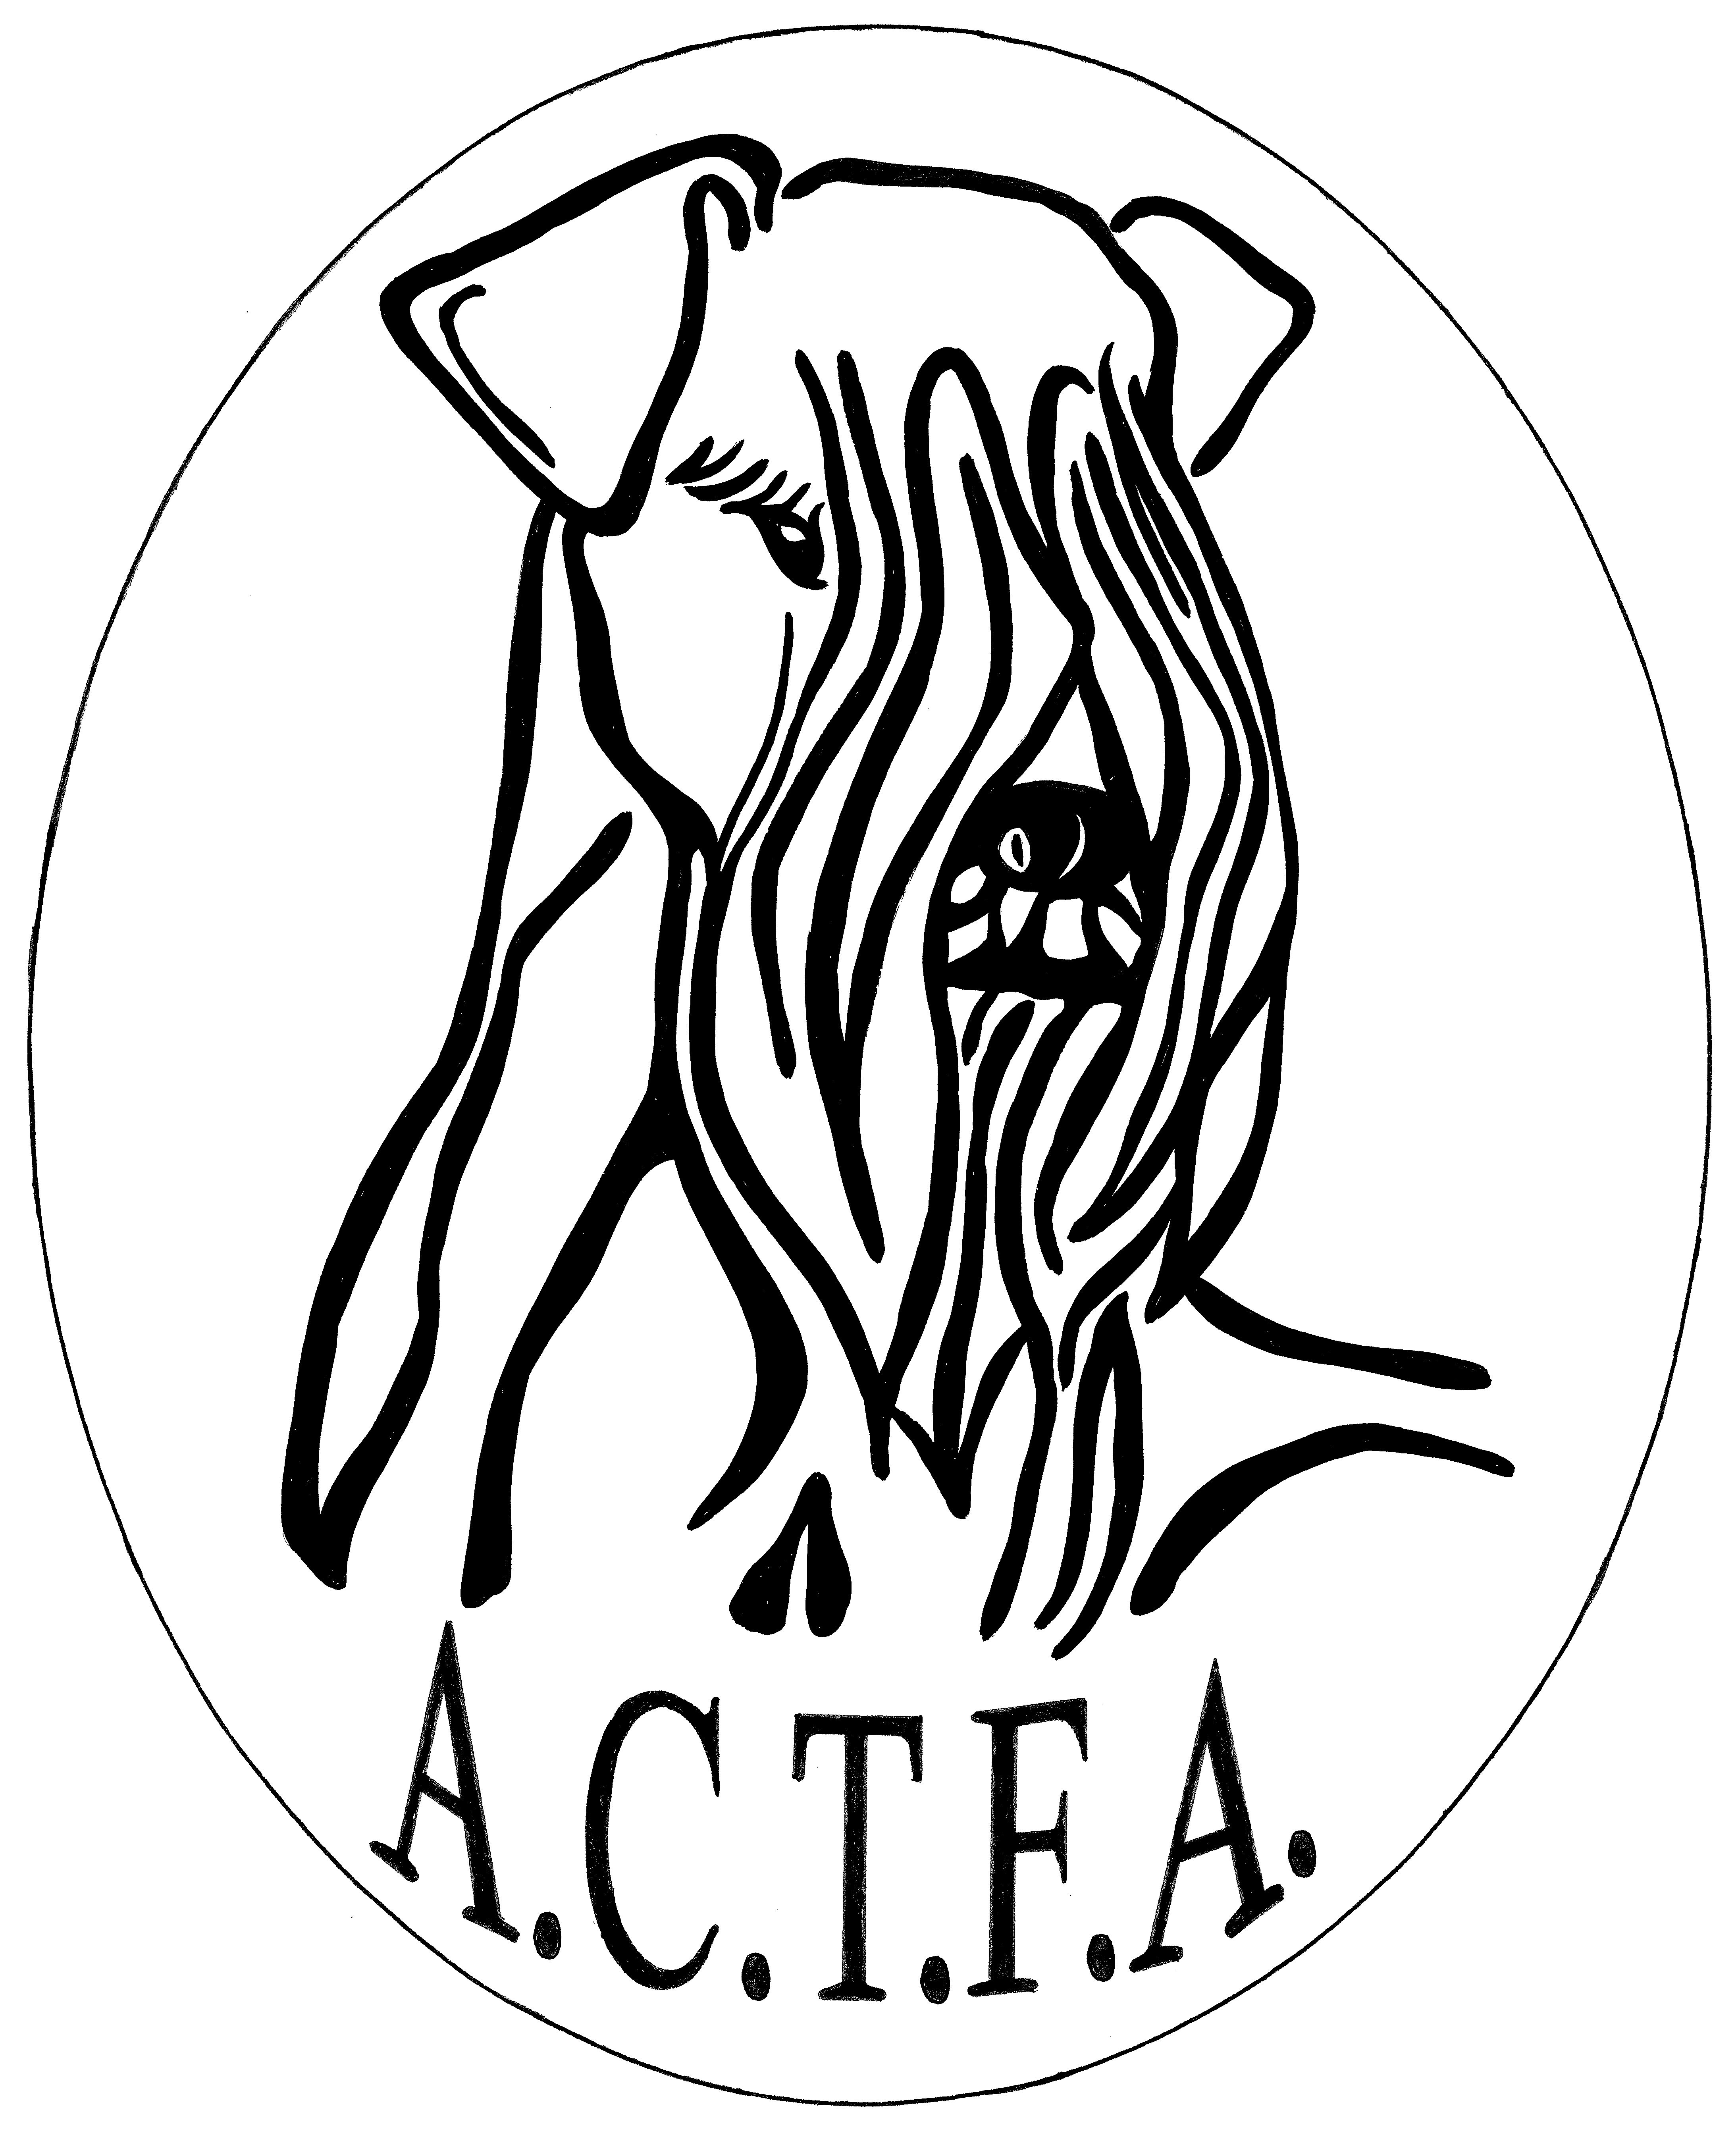

The American Cesky Terrier
Fanciers Association, Inc.

Application for Membership Renewal 2023

Please sign and return the ACTFA membership renewal form by 31 Dec 2022. Include a check/money order (US dollars) made out to:

ACTFA, Inc., and mail to: Sandra Bridge-Chase, 24719 71st Ave N., Port Byron, IL 61275

Or use PayPal – treasactfa@gmail.com Late Membership renewals will be accepted through 2 March 2023 with board approval.

The enclosed check is for the following Membership Category:
Voting Non - Voting
_____$20 – Regular (1) _____ $20 – Associate (1)

_____$30 – Household (2) _____$0 – Junior under age 18

_____$20 – International (1)

_____$30 International Household (2)

I hereby make my renewal application for membership in the American Cesky Terrier Fanciers Association, Inc. I understand that membership in the ACTFA is a privilege, not a right. I accept and agree to abide by the Constitution By Laws and Code of Ethics of the Club and the rules of the AKC. I clearly understand that my membership is on a year-to-year basis and that dues are payable on 2 January of each year.

______________________________ _________________
Signature Date

_____________________________ _________________
Signature Date
Additional Donation:

_____$100 – Platinum Donation _____ $75 – Gold Donation

____$50 – Silver Donation _____$25 – Bronze Donation

Or donate any amount to the following: _____ Rescue _____ Education

______Trophies _______ Membership Renewal Gift

******************************************************************
ACTIVE MEMBERSHIP (Voting)

_____________Regular Membership. One person age 18 years or older who, at the time of application, is a resident of the United States and once owned/co-owned or currently owns/co-owns a Cesky Terrier registered with the American Kennel Club. (Cost $20)

_____________Household Membership. Two (2) people, ages 18 years or older and residing in the same household, who are residents of the United States and one of whom once owned/owns or currently owns/co-owns a Cesky Terrier registered with the American Kennel Club. (Cost $30)

ASSOCIATE MEMBERSHIP (Non-Voting, Not eligible to hold office)

______________Associate Membership. One person age 18 years or older who, at the time of application, is a resident of the United States. (Cost $20)

JUNIOR MEMBERSHIP (Non-Voting, Not eligible to hold office)

______________Junior Membership. One person under 18 years of age. Junior membership will automatically convert to regular membership upon turning 18. (No Dues, provide Birthdate)

INTERNATIONAL MEMBERSHIP (Non-Voting, Not eligible to hold office)

_______________International Membership. One non-US resident 18 years of age or older. (Cost $20)

_______________International Household Membership. Two (2) people, aged 18 years or older, non-US residents, and residing in same household. (Cost $30)
Please update any changes to you address below:
Name
Address
City, State, Zip
Home Phone
Cell Phone
Email

MEMBERSHIP RENEWAL GIFT 2023

MEMBERSHIP RENEWAL GIFT ?????

We are still researching a great gift and will send a separate email when we have selected the 2023 renewal gift.

